Lab: Vector Force Table

Purpose
In this lab we explore Newton's 1st Law: 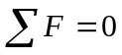 at equilibrium and Newton's 2nd Law: F = ma using vector forces on a force table. For the first half of the experiment, equilibrium for three vectors will be investigated by resolving each force into its vector components. In the second part of the lab, vector addition will be explored by finding a resultant between two added vectors and verifying your result using a third vector.

Method
A force table system is used under specified conditions to simulate the addition and subtraction of vectors. The vectors are created by hanging various gram masses from strings that are draped over pulleys and connected to a moveable ring near the center of the force table. The ring, when suspended off the table and centered, represents equilibrium in the system. For our purposes we will ignore friction at the pulleys.

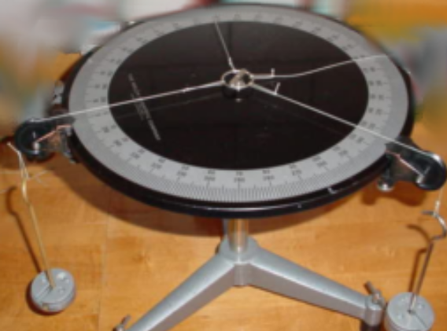
Force Table System

Procedure and Analysis, Part 1

- Set up your vector table as shown above making sure that the middle ring is in equilibrium (i.e. the ring is not touching the center post on the vector table. Be sure to use various masses at each pulley to create your vectors at different angles.
- For each of the vector string forces, the magnitude of the force can be found by using F = ma where m is the mass of the gram masses measured in kilograms, and a is the acceleration due to gravity: 9.8 m/s² . Show your calculations for finding the magnitude of each of the three vector forces - 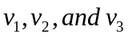.

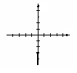
- Draw your vectors onto the coordinate system provided. The angles of the vectors from the horizontal should be correctly shown and the magnitudes of the vectors should be proportionately represented. Use a protractor and ruler, if you have them. Otherwise draw them as accurately as you can.

- Now resolve all three vectors into 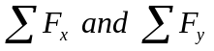. If you truly have equilibrium, what should each of these two sums equal? Show calculations to support your answer.

Procedure and Analysis, Part 2

- For this part of the lab you will use the same set of three vectors from Part I.

- Now resolve any two of the vectors into to find the resultant vector. Show your calculations.

- Once again, draw your vectors onto the coordinate system provided below AND include your drawing of the resultant vector associated with the addition of the two vectors you chose to add in ‘a)’ above.

- What should the relationship be between the resultant vector found in step 5. and the third vector in your system? Did you find the conjectured relationship to be true for your system? Support your answer.

Conclusion

- Was there error present in your system? If so, what are some of the sources of error?

- What conclusions are you able to make concerning your results keeping in mind the "purpose" of the lab from above?

