Analytical Definitions of Conic Sections
We visualize each conic section as the intersection of a plane with a right circular cone (see Figures A, B, and C).
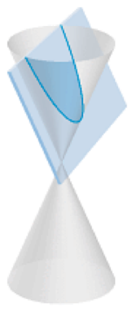 | 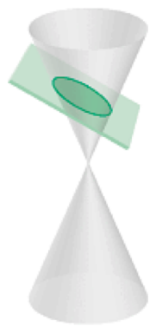 | 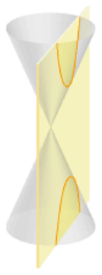
Figure A  Parabola | Figure B  Ellipse | Figure C  Hyperbola
Depending on the orientation of the plane, the resulting curve can be a parabola, ellipse, circle, or hyperbola (with degenerate forms: point and line).

PARABOLA
We define a parabola (see Figure 1) to be the set of all points that are equidistant from a fixed point (called the focus) and a line (called the directrix). A special point on the parabola is the vertex, the midpoint of the perpendicular segment from the focus to the directrix.
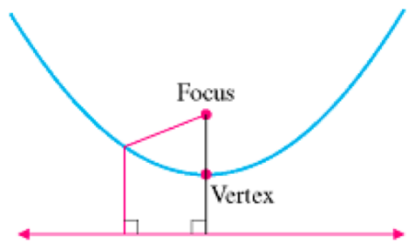
Figure 1

ELLIPSE
We define an ellipse to be the set of all points for which the sum of the distances to two fixed points (called foci, the plural of focus) is constant. This definition is illustrated in Figure 2. We define the center of an ellipse to be the midpoint of the line segment connecting the foci.
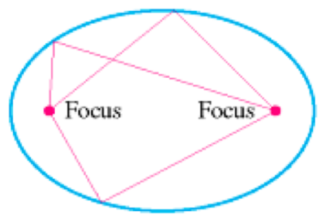
Figure 2

HYPERBOLA
We define a hyperbola to be the set of all points such that the difference of the distances between two fixed points (called the foci) is a constant. This definition is illustrated in Figure 3. Notice that it is nearly identical to the definition of the ellipse, except that we subtract the distances instead of adding them.
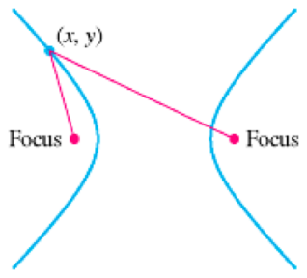
Figure 3

CIRCLE

(As has been previously discussed)

